PRACTICAL

EXPERIMENT 1

DDL Commands – CREATE, ALTER, DROP

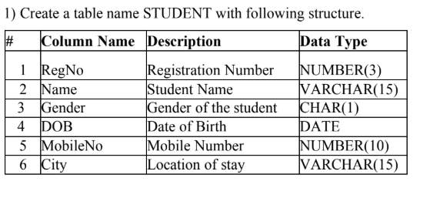
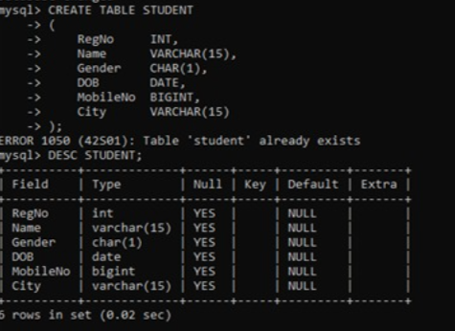

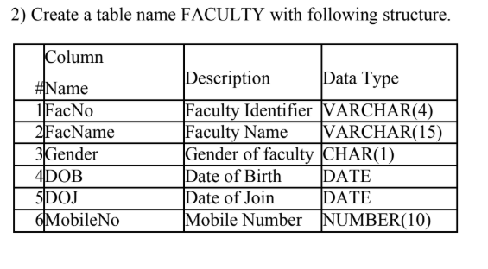

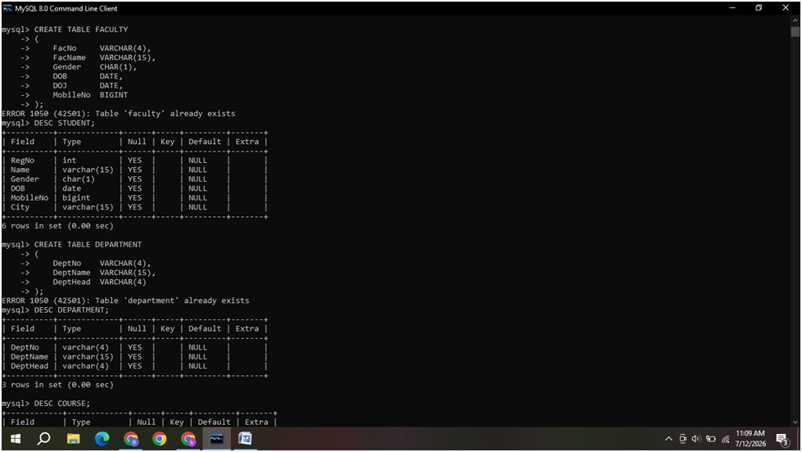

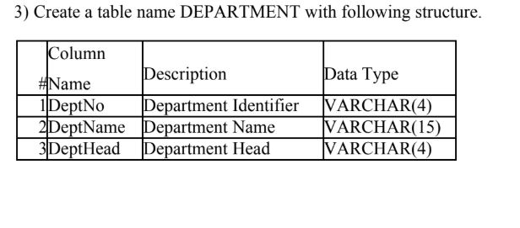
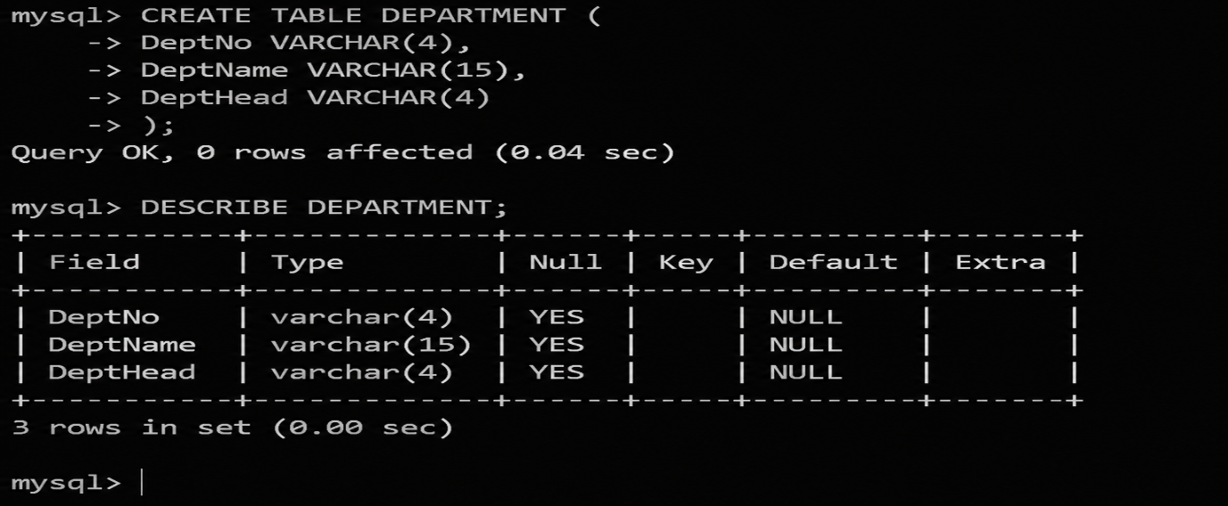

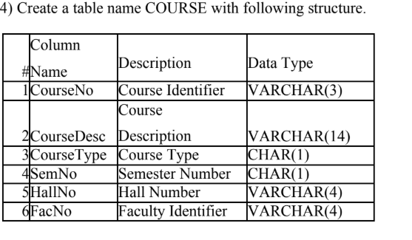

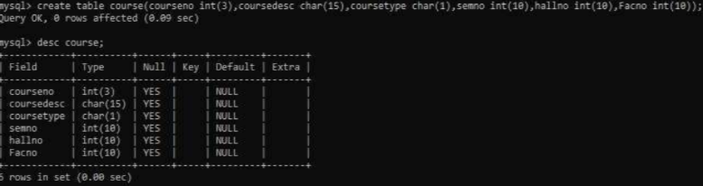

5) Modify the table FACULTY by adding a column name Dept of datatype VARCHAR(10)

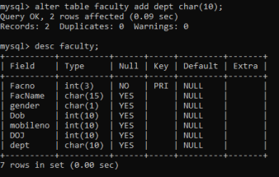

EXPERIMENT NO:2

DDL Commands with Constraints – PRIMARY, FOREIGN KEY, UNIQUE, CHECK

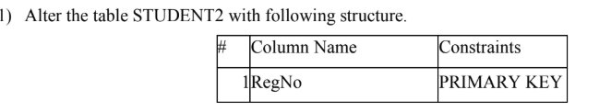

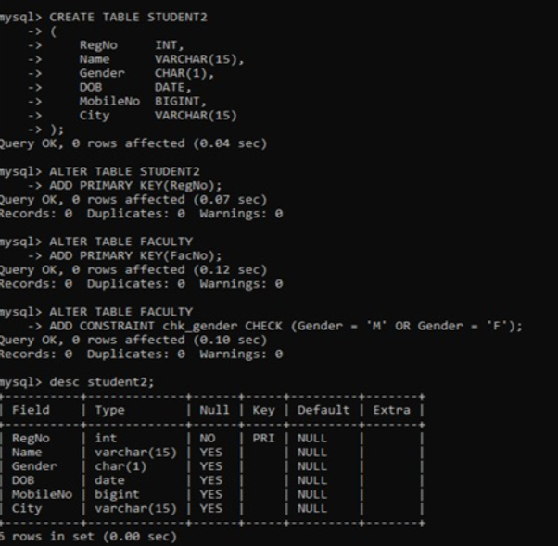

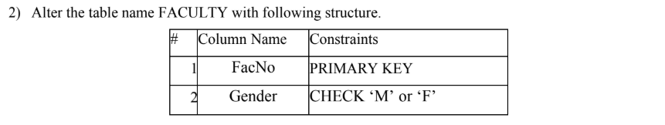



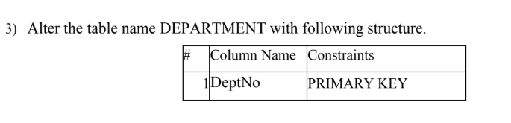
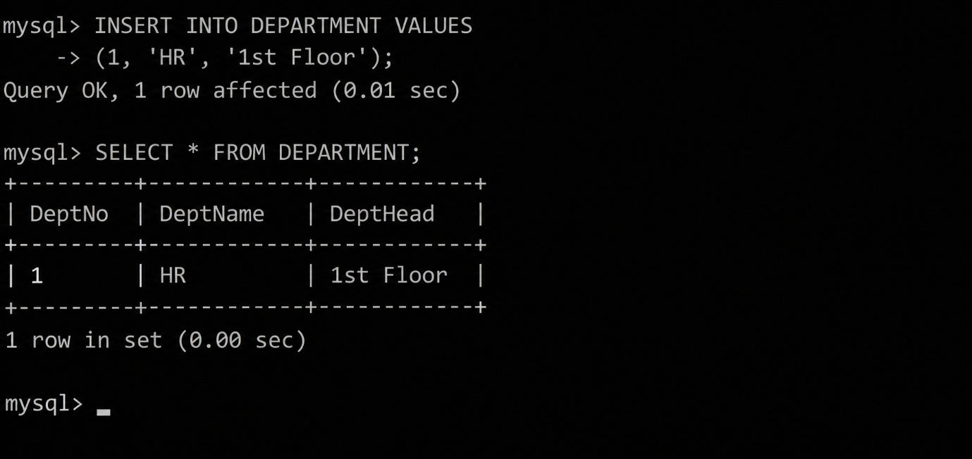

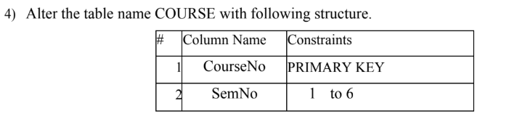
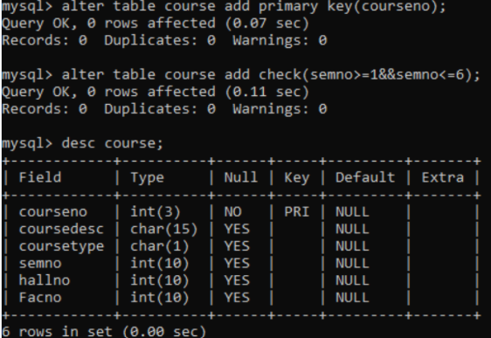

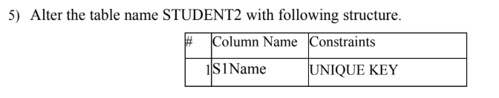

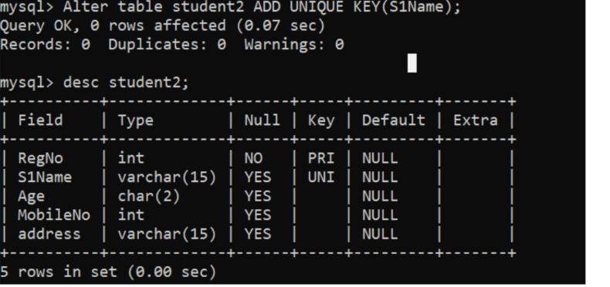
6) After the STUDENT2 & STUDENT3 tables are successfully created, test if you can add a constraint
FOREIGN KEY to the RegNo of this table.

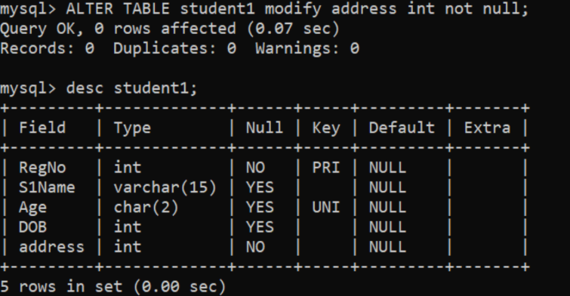

EXPERIMENT-3
DML Commands – INSERT, SELECT
- Populate all the five tables with your own data.
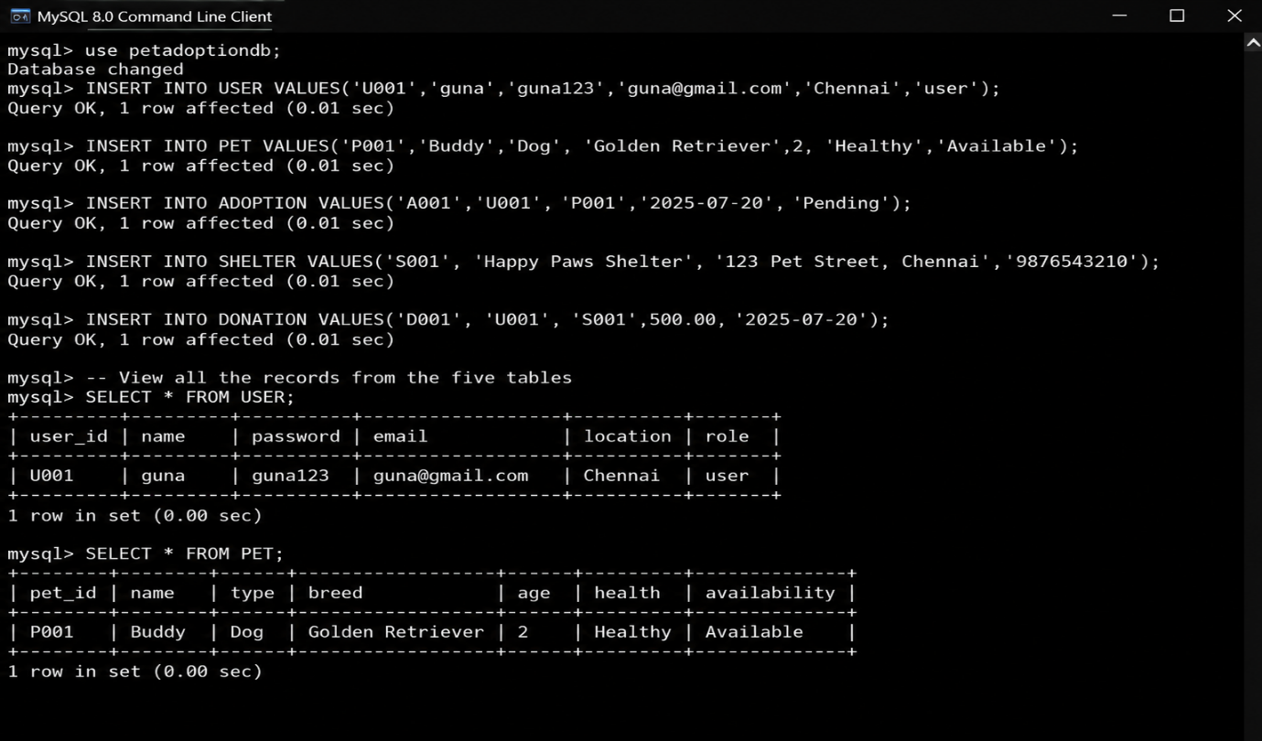
- View all the records from the five tables.
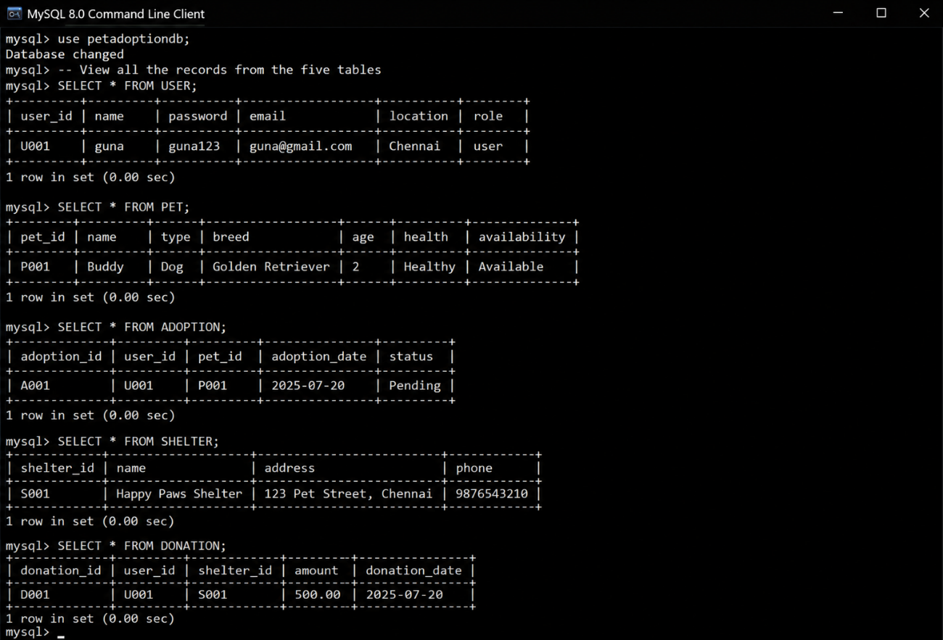
EXPERIMENT-4
DML Commands with Constraints –UPDATE, DELETE
1. Update the value of student name whose register number is ‘191711342’
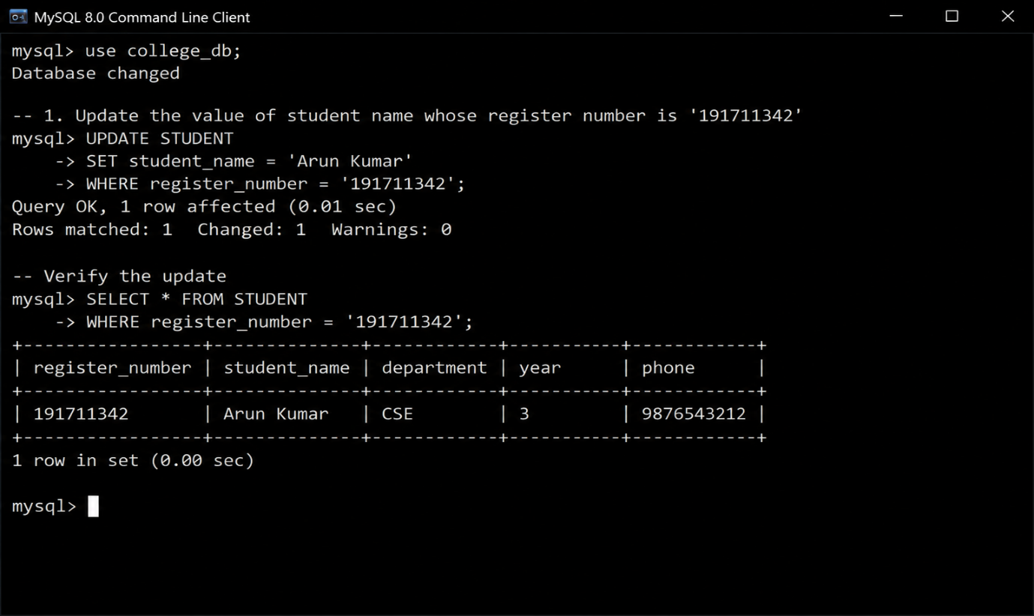
2.Delete the record in the table FACULTY, who resigned her job.
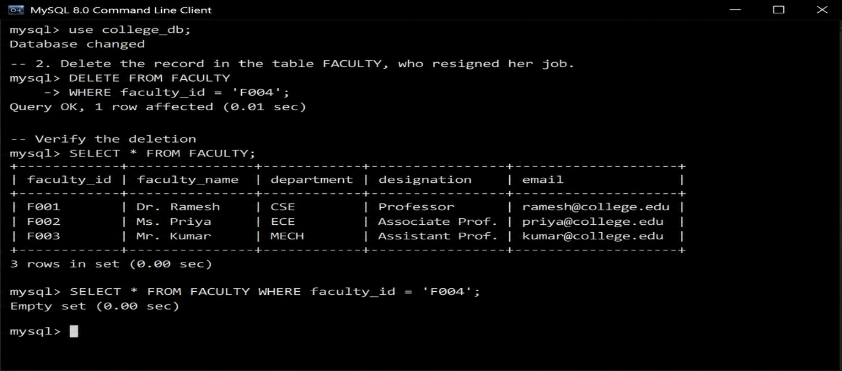
- Modify the age for the faculty whose name is 'mohan' with a value ‘59’.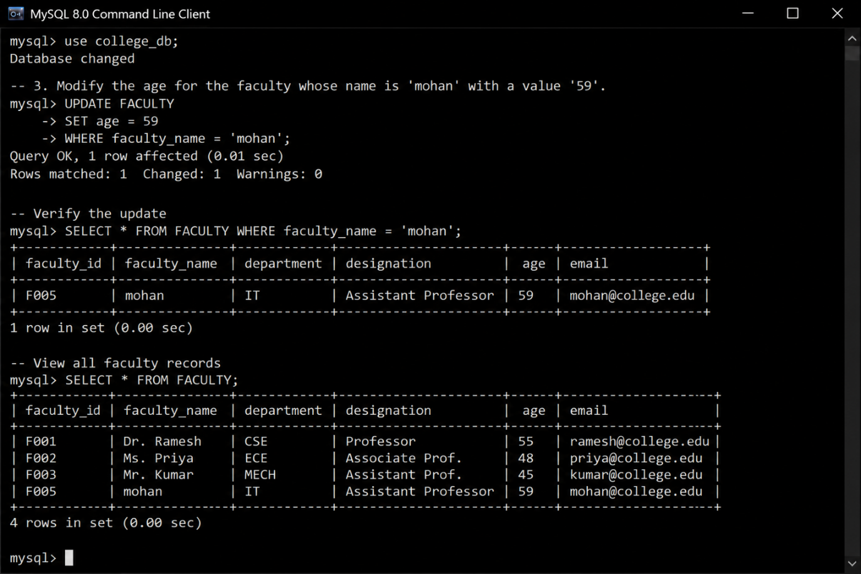
- Remove all faculty who are having over 65 years
